**Data Analysis and Visualization -Practice -2**

**Data Visualization in Excel**

Exercise :1

Selecting car sales data to compare sales for men and women, using various different chart types.

|  |  |  |
| --- | --- | --- |
| Car Sales By Gender | | |
|  |  |  |
|  | Men | Women |
| Fiat | 3% | 32% |
| Ford | 39% | 12% |
| BMW | 21% | 8% |
| Mercedes | 6% | 17% |
| Vauxhall | 19% | 10% |
| Nissan | 12% | 21% |

Create a 3-dimensional column chart comparing sales data for men and women, but omitting BMWs

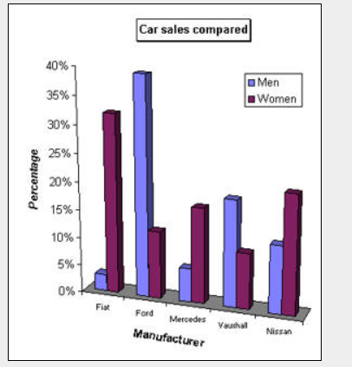

The main changes to make to the default chart created are:

* A chart title and category and value axis label have been added
* The gridlines and background colour have been removed
* The legend has been moved
* The category axis label **Manufacturer** has been rotated slightly

Save this as **Car Sales without BMWs**, and close it down.

Exercise :2

Create a chart to compare the favourite films data for 15-25 year olds only (be careful not to include any unnecessary blanks rows or columns in your selected data).

|  |  |  |  |  |
| --- | --- | --- | --- | --- |
| Favourite Films By Age group | | | | |
|  |  |  |  |  |
|  |  | **15 - 25 yrs** | **26 - 40 yrs** | **Over 40's** |
|  |  |  |  |  |
| **Barbarella** |  | 17% | 31% | 18% |
| **Die Hard** |  | 20% | 15% | 1% |
| **Gone with the Wind** |  | 4% | 19% | 41% |
| **Jurassic Park** |  | 34% | 12% | 3% |
| **Speed** |  | 17% | 8% | 11% |
| **Titanic** |  | 8% | 15% | 26% |
|  |  |  |  |  |
| % denotes the percentage of the sample that marked the film as their favourite. | | | | |

Format this chart so that it is a pie chart, with the **Barbarella** slice "exploded" and each segment labelled:

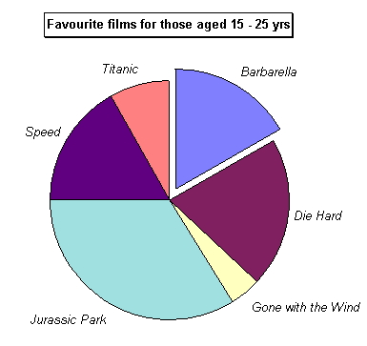

*A chart title has also been added*

Save this as **Favourite Films**    and close it down.

Exercise :3

|  |  |
| --- | --- |
| Favourite Cheeses Data | |
|  |  |
| Cheese Type | Number of People |
| Brie | 9 |
| Cheddar | 23 |
| Cheshire | 7 |
| Dairylea | 9 |
| Lancashire | 8 |
| Other | 7 |
| Red Leicester | 14 |
| Stilton | 11 |
| Wensleydale | 12 |

When you have the right data selected, create a pie chart similar to the example shown below:

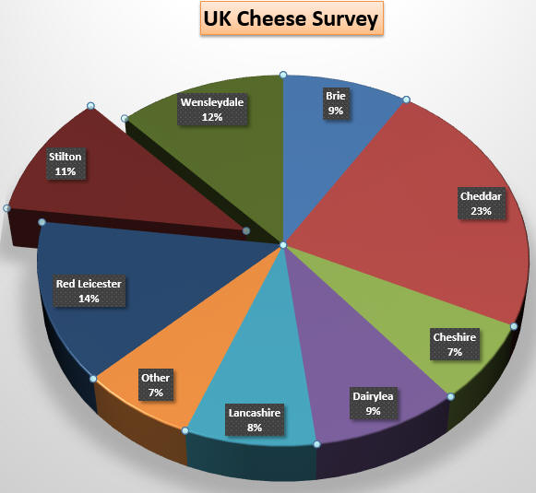

In your selection, make sure to omit**Dairylea**and**Others**, then create a pie chart similar to the one shown

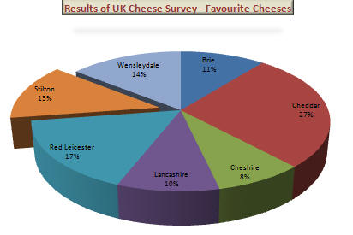

Exercise :4

|  |  |
| --- | --- |
| **Weight of trainer** | |
|  |  |
| **Day** | **Pounds** |
| 1 | 168 |
| 2 | 167 |
| 3 | 168 |
| 4 | 168 |
| 5 | 165 |
| 6 | 167 |
| 7 | 165 |
| 8 | 166 |
| 9 | 164 |
| 10 | 165 |
| 11 | 164 |
| 12 | 167 |
| 13 | 166 |
| 14 | 167 |
| 15 | 162 |
| 16 | 164 |
| 17 | 164 |
| 18 | 165 |
| 19 | 163 |
| 20 | 163 |
| 21 | 165 |
| 22 | 165 |
| 23 | 165 |
| 24 | 166 |
| 25 | 164 |
| 26 | 164 |
| 27 | 165 |
| 28 | 165 |

Make the necessary formatting changes so it resembles the example shown below - add any of your own changes!

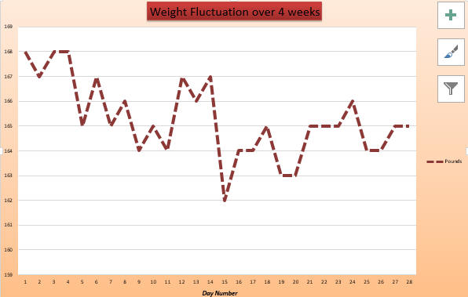

Exercise:5

Check with chocolate bar favourites and select the data for just the UK and France:

|  |  |  |  |  |
| --- | --- | --- | --- | --- |
| **Chocolate Bar Favourites** | |  |  |  |
|  |  |  |  |  |
| **Item** | **UK** | **France** | **USA** | **Germany** |
| Crunchie | 12 | 1 | 2 | 5 |
| Mars Bar | 25 | 7 | 11 | 23 |
| Yorkie | 8 | 2 | 1 | 3 |
| Dairy Crunch | 1 | 1 | 7 | 5 |
| Cadburys Dairy Milk | 18 | 13 | 9 | 9 |
| Snickers | 6 | 1 | 11 | 11 |
| Hershey Bar | 2 | 8 | 38 | 6 |
| Lindt Lindor Bar | 4 | 39 | 5 | 22 |
| KitKat | 20 | 17 | 14 | 12 |
| Dime Bar | 4 | 11 | 2 | 4 |
| **TOTAL** | **100** | **100** | **100** | **100** |

Create a 3D Column chart similar to the one shown below:

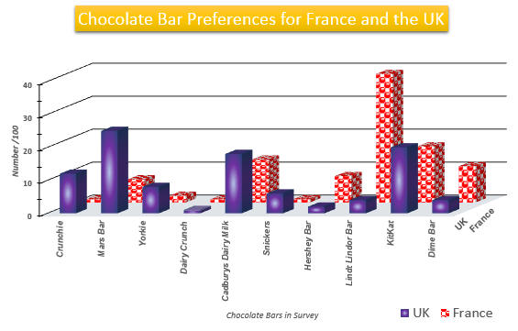

Exercise :6

|  |  |  |  |
| --- | --- | --- | --- |
| **Rank** | **City** | **Country** | **Population  (Urban - City Limits)** |
| 1 | Shanghai | China | 1,46,08,512 |
| 2 | Mumbai (Bombay) | India | 1,26,91,836 |
| 3 | Karachi | Pakistan | 1,16,24,219 |
| 4 | Buenos Aires | Argentina | 1,15,74,205 |
| 5 | Dilli (Delhi) | India | 1,09,27,986 |
| 6 | Manila | Philippines | 1,04,44,527 |
| 7 | Moscow | Russia | 1,03,81,222 |
| 8 | Seoul | Korea (South) | 1,03,49,312 |
| 9 | Sao Paulo | Brazil | 1,02,10,295 |
| 10 | Istanbul | Turkey | 97,92,428 |

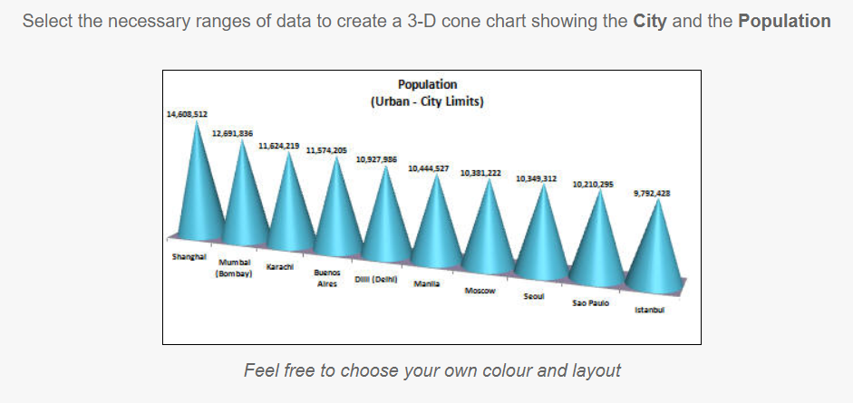

Exercise :7

|  |  |
| --- | --- |
| **Munchkins Sales Trends** | |
|  |  |
| **Sales** | **Year** |
| £23,800 | 2008 |
| £26,400 | 2009 |
| £23,700 | 2010 |
| £31,900 | 2011 |
| £28,500 | 2012 |
| £32,700 | 2013 |
| £35,700 | 2014 |
| £29,500 | 2015 |
| £37,500 | 2016 |
| £39,700 | 2017 |

Change the chart type to a **Scatter** chart and change the axis scale to start at 20000 and end at 40000.  You might also like to edit the marker and the grid options.  Your **Scatter** chart should now be similar to this:

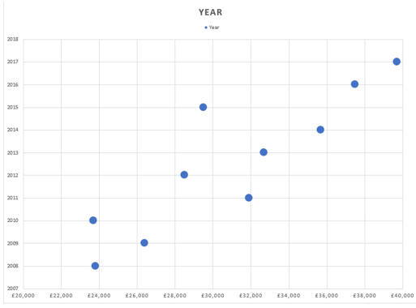

*The next step is to add a regression****Trendline****.*

Select the scatter chart markers and ask Excel to insert a **Trendline**:

